Sections 6.1, 6.2 Hypothesis Testing in Regression
Regression equation $\hat{y}=\hat{intercept} +\hat{slope}\left(x\right)$
$\left(SE_{intercept}\right)$ $\left(SE_{slope}\right)$
Hypothesis testing
Step 1: Set out hypotheses | $$H_{0}:coefficient=0$$  $$H_{a}:coefficient≠0$$ | $H_{0}:$ there is zero relation between Y and X  $H_{a}:$ there is a relation between Y and X
Step 2: calculate the test statistic | $$test statistic=\frac{coefficient}{Std. err.}$$ | Estimated effect compared to the typical estimation error.
Step 3: find the P-value | 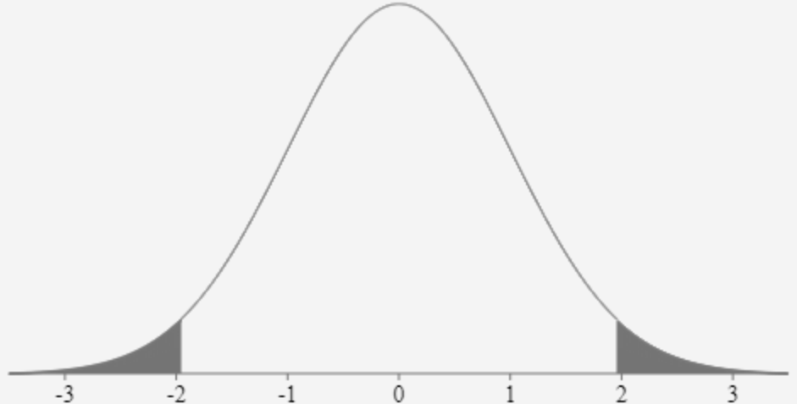 | Likelihood of an error this big, or even bigger, if the hypothesis is true.
Step 4: draw a conclusion | There is no evidence of a relation if  t < 1.96 or if P>0.05.  There is evidence of a relation if  t > 1.96 or if P < 0.05. | Judgment of whether the evidence confirms the null hypothesis  or rejects it.
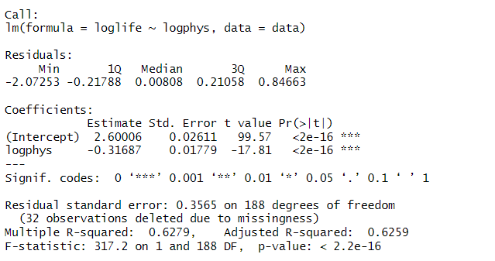
Regression equation $_____________=_____________+___________\left(______________\right)$
$\left(______________\right)$ $\left(______________\right)$
Hypothesis testing
Step 1: Set out hypotheses | $$H_{0}:coefficient=0$$  $$H_{a}:coefficient≠0$$ | $H_{0}:$ there is zero relation between Y and X  $H_{a}:$ there is a relation between Y and X
Step 2: calculate the test statistic | $$test statistic=\frac{coefficient}{Std. err.}=$$ | Estimated effect compared to the typical estimation error.
Step 3: find the P-value |  | Likelihood of an error this big, or even bigger, if the hypothesis is true.
Step 4: draw a conclusion | Is there’s evidence of a relation? | Judgment of whether the evidence confirms the null hypothesis  or rejects it.
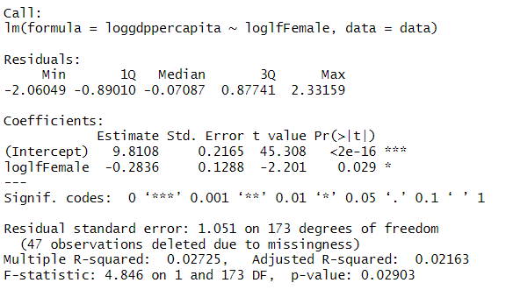 |  |  | What’s the null hypothesis?  t = _____  P = _____  Conclusion
Regression equation $_____________=_____________+___________\left(______________\right)$
$\left(______________\right)$ $\left(______________\right)$
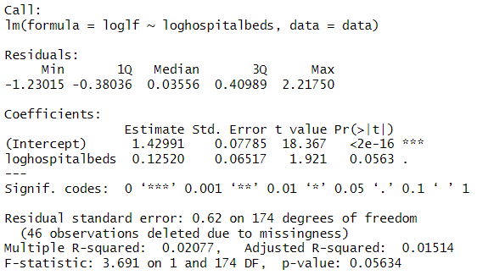 | What’s the null hypothesis?  t = _____  P = _____  Conclusion
Regression equation $_____________=_____________+___________\left(______________\right)$
$\left(______________\right)$ $\left(______________\right)$
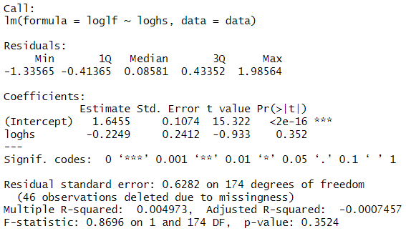 | What’s the null hypothesis?  t = _____  P = _____  Conclusion
Regression equation $_____________=_____________+___________\left(______________\right)$
$\left(______________\right)$ $\left(______________\right)$

